Linux Test : 30 Jan 2017

Que : 1 Write command sequence for finding files having .c extension in
/home/user_name directory and save it at /home/user_name/cfiles.txt. Currently
you are in /lib directory.

ankitgajera@AnkitGajera:/lib$ find /home/ankitgajera/ -name '*.c' > /home/ankitgajera/cfiles.txt

Que : 2 Write a shell script to find factorial of a number entered at run time.

Fact.sh

echo "Enter the number to find factorial : "
read x
n=$x;
fact=1
while [ $n -ge 1 ]
do
fact=$(($fact*$n))
n=`expr $n - 1`
done

echo Factorial of $x is : $fact

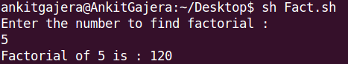

Que 3:Write command to remove executable permission to your file created in previous 5
question and then try to execute that same shell script file without execute
permission. Will it allow by any means?

After removing permission, it won't allow to execute the script but we can run our script using sh command.

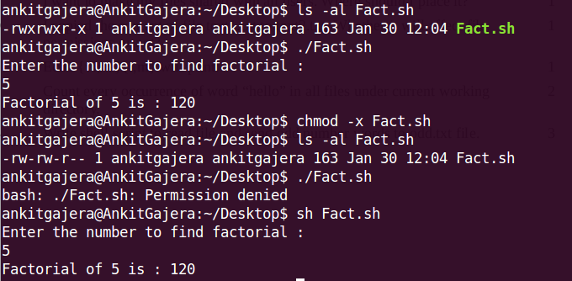
Que 4: Write shell script to find number of files in a directory /bin

Que 5 :Make dir one inside two;which is inside three;which is inside four .... till ten
using single command. I.e ten/nine/eight....two/one

mkdir ten/ ten/nine/ ten/nine/eight/ ten/nine/eight/seven ten/nine/eight/seven/six ten/nine/eight/seven/six/five ten/nine/eight/seven/six/five/four ten/nine/eight/seven/six/five/four/three ten/nine/eight/seven/six/five/four/three/two ten/nine/eight/seven/six/five/four/three/two/one

Que 6 : I have several files; find file names having “good” in it's content.

grep "good" `find /home/ankitgajera/Desktop/ -name "*.*" -print`

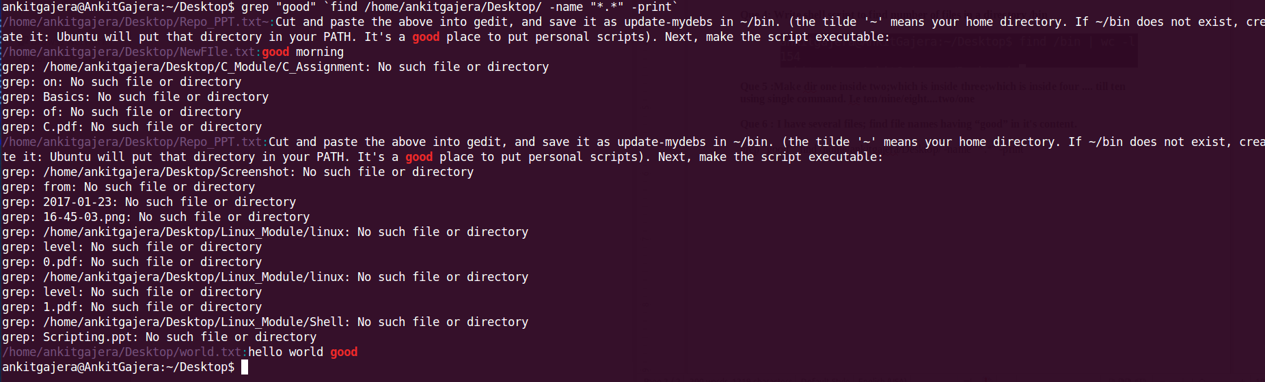
Que 7 : What is the difference between files in /bin and in /sbin?

The directories basically stores the binaries only but main difference is that where they binaries are being used in system and who are using it.

/bin : contains the binaries that are system wide and any user or group or others can use it.
/sbin : contains the binaries that are also system wide but used only by super user or root user.

Que 8 : I want to display msg “hello ubuntu” at boot time;when ubuntu is loading. Where should I configure this?

You can configure it in /etc/default/grub file where GRUB_CMDLINE_LINUX variable is there.
Just assign “hello ubuntu” to that variable.

Que 9 : I want to make my files shared with all users. Where should I place it?

You can put files in /home directory.

Que 10 :I copied the content of file text1.txt to text2.txt. Whether it will affect file
permissions or not?

No, It won't affect the permissions.

Que 11 : Echo {vi,na}{i,m} will print:

vii vim nai nam

Que 12: Count every occurrence of word “hello” in all files under current working
directory.

Grep “good” `find . -name “*.*”` | wc -l

Que 13: Write shell script to read file and send odd number words to odd.txt file.

